# Ryan Timbrook

## IST 659 Data Admin Concepts &Db Mgmt

## Date: 9/17/2018

## Lab Assignment: Lab 10, Using Your Database

## Description / Learning Objective

* Demonstrate proficiency in using software to connect to a database server and manipulate the database contents.

## Responses

### Part 1 – Creating a Graphical User Interface (GUI)

Prototype an interface that allows a user to manage vc_User and vc_UserLogin records.

P1-TODO-1: Screen Prints, Users form and UserLogin subform

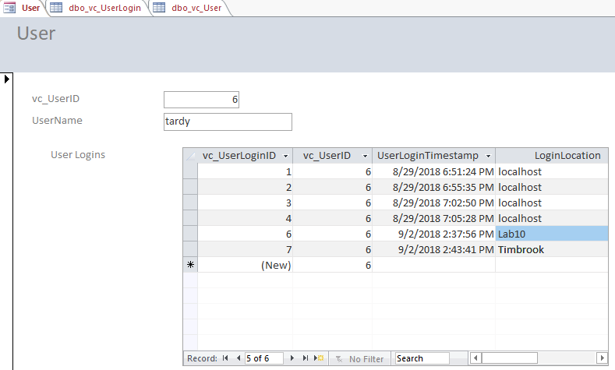

P1-TOD0-1: Q&A

Q1: If we only provided a value for LoginLocation, how did the software know what to use for vc_UserLoginID and UserLoginTimestamp?

A1: vc_UserLoginID is an autogenerated surrogate primary key. SQL Server will generate this field when a new record is inserted into the vc_UserLogin table. The UserLoginTimestamp field has a default function, getdate(), associated to it as well as is defined as not null. SQL Server will autogenerate and populate this field with the timestamp of when the new record was created on the vc_UserLogin table. Access, as the software tool for enabling the insert of these records has this capability based on the ODBC connections we created.

##### Q2: Based on what the behavior we saw and the form/subform relationship, how did the software know which vc_UserID to use for the vc_UserLogin record?

A2: Access was able to know which vc_UserID to use based on the Relationship we made when linking the vc_User and vc_UserLogin tables. This binding follows the referential integrity constraints we imposed on these two tables when we created them, where the vc_UserID of the vc_UserLogin table is the foreign key of the vc_User tables vc_UserID primary key. Because of how we structured the Access form and subform, the vc_UserLogin table is linked to a specific record of the vc_User table. Since we navigated to the ‘tardy’ User record, this was the vc_UserID that was selected by Access to insert into the vc_UserLogin table.

##### Q3: What are some pros and cons (at least 2 of each) to using Access to manage SQL Server data?

A3-PRO-1:

Access Forms are a powerful tool for inputting data and visualizing data simple for the end user to understand.

A3-PRO-2:

One benefit of access is its Jet Database format, which contains not only the application but also the data in one file. The ability to have the application and data in one file makes it very convenient to distribute the entire application to various users who can run the application in disconnected environments.

A3-CON-1:

With Access each client reads and writes directly to the raw data tables. If a client machine crashes while writing data, this will usually cause the back-end database to also crash and become corrupt.

A3-CON-2:

Access is a client File Server design that is not intended to be used with high-stress, high-concurrency server applications. Such systems, when used with Access, have issues of database corruption.

### Part 2 – Using R to Connect to SQL Server

P2-TODO-1: Screen Print, sqlResult data object

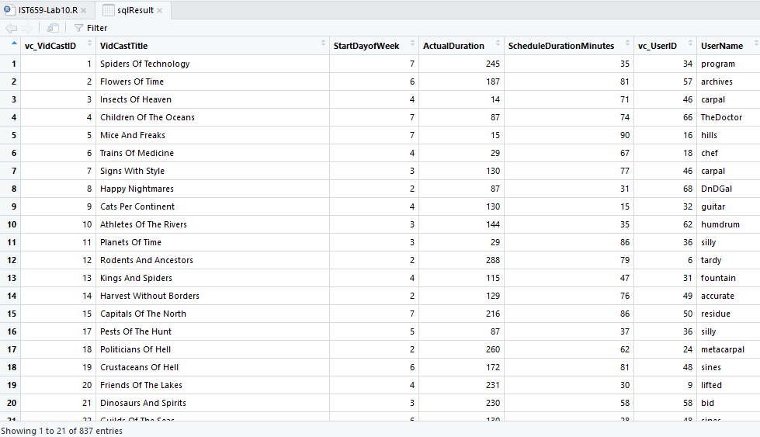

P2-TODO-2: Import graph plots images

|  |  |
| --- | --- |
| VidCastHist | VidCastCount |

P2-TODO-2: Q&A

Q1: In reference to the script in step 4, what does the SQL code on line 12 do?

A1: DatePart is an SQL Server Function which returns a specified part of a given date as an integer. The input parameter, or interval, of ‘dw’ tells the server the return value should be the weekday.

##### Q2: What is one way to simplify lines 8 through 19?

A2: Remove lines 15, 16, and 18. The User attributes requiring the table JOIN aren’t being used elsewhere in the script and are not part of the graphic plots.